ACKNOWLEDGEMENT

I sincerely thank my project guide, PROF. BINDIYA, for their guidance and support throughout this project. I also thank the faculty of the Computer Science Department for their encouragement.  
  
Finally, I am grateful to my family and friends who supported me during the completion of this project.  
  
JOSHI MITANSHI | MEHTA VEDANSHI

**Table of Contents:**

|  |  |  |
| --- | --- | --- |
| **Sr. No.** | **Title** | **Page No.** |
| 1 | Introduction and objective | 01 |
| 2 | System Analysis | 02 |
| 3 | Data Dictionary | 03 |
| 4 | System Design |  |
|  | 4.1 : Context Diagram | 12 |
|  | 4.2 : Data Flow Diagram (DFD) | 13 |
|  | 4.3 : ER Diagram | 16 |
| 5 | Implementation |  |
|  | 5.1 : Screenshots & code explaination | 17 |
| 6 | Testing and reasult | 25 |
| 7 | Conclusion & Future Scope | 27 |

1. **Introduction & Objective:**

**Introduction:**

**The Car Rental Management System is a software solution designed to manage rental operations such as vehicle booking, customer registration, rental history, payments, and car availability. It replaces manual paperwork with a digital system to increase accuracy, speed, and efficiency.**

**Objective:**

**- Automate the car booking and return process.**

**- Maintain customer and vehicle records efficiently.**

**- Generate bills and rental summaries automatically.**

**- Improve operational efficiency and reduce manual errors.**

1. System Analysis:

Problem Definition:

Managing rental operations manually is time-consuming and error-prone. Tracking car availability, customer records, and invoices becomes difficult using traditional methods. This system automates these processes to avoid human errors and improve workflow efficiency.

Feasibility Study:

Technical Feasibility: Can be developed using C#.Net, Python, or any modern development framework.Operational Feasibility: Easy to use for staff and administrators.Economic Feasibility: Low development and maintenance cost due to open-source tools.

3.Data Dictionary

* + - A database is an organized collection of data. It is collection of schemes, tables, queries, views and other objects. There are some tables are available in this project that listed below:
      * 1. users
        2. cars
        3. bookings
        4. payment
        5. car_categories
        6. userdetails
        7. booking
        8. admin

[1.users]

|  |  |  |  |
| --- | --- | --- | --- |
| Field | Type | Size | Extra |
| id | Int | 11 | Not Null |
| fullname | Varchar | 50 | Not Null |
| email | Varchar | 20 | Not Null |
| username | varchar | 50 | Not Null |
| password | Varchar | 50 | Not Null |
| Profile_pic | varchar | 20 | Not Null |

* + This table is used to store the information about Users Register. It can store First Name, Last Name, UserName, Password, Email, profile picture and etc.

[2.cars]

|  |  |  |  |
| --- | --- | --- | --- |
| Field | Type | Size | Extra |
| id | Int | 11 | Not Null |
| Car_name | Varchar | 50 | Not Null |
| Car_brand | Varchar | 50 | Not Null |
| Car_model | year | 50 | Not Null |
| Car_type | Varchar | 50 | Not Null |
| Fuel_type | Varchar | 10 | Not Null |
| Transmission | Varchar | 20 | Not Null |
| Seats | int | 50 | Not Null |
| Price_hour | decimal | 10.2 | Not Null |
| Price_day | decimal | 10.2 | Not Null |
| Availability | enum | 5 | Not Null |
| Reg_no | Varchar | 50 | Not Null |
| Facilities | text |  | Not Null |
| Image | varchar |  |  |
| Description | text |  |  |
| Created_at | timestamp |  |  |

This table is used to store car information.It can store car name,brand,type,fuel,date and etc.

[3.bookings]

|  |  |  |  |
| --- | --- | --- | --- |
| Field | Type | Size | Extra |
| id | Int | 11 | Not Null |
| User_id | int | 50 | Not Null |
| Car_id | int | 50 | Not Null |
| name | Varchar | 50 | Not Null |
| email | Varchar | 50 | Not Null |
| phone | varchar | 20 | Not Null |
| Start_date | date |  | Not Null |
| End_date | date |  | Not Null |
| Total_amount | decimal | 10,2 | Not Null |
| Status | varchar | 20 | Not Null |
| Aadhar_image | varchar |  | Not Null |
| location | Varchar | 50 | Not Null |
| Payment_method | varchar |  | Not Null |

This table is used to store user bookings information.It is stored booking id,name,email,phone,date,amount etc...

[4.payment]

|  |  |  |  |
| --- | --- | --- | --- |
| Field | Type | Size | Extra |
| Payment_id | Int | 11 | Not Null |
| Booking_id | int | 11 | Not Null |
| amount | decimal | 10.2 | Not Null |
| Payment_method | Enum  (cash,card) | 10 | Not Null |
| Payment_date | date | 50 | Not Null |
| status | enum |  | yes |

This table is used to store payment information. It is store payment id, booking id,amount , payment method etc…

[5.userdetails]

|  |  |  |  |
| --- | --- | --- | --- |
| Field | Type | Size | Extra |
| id | Int | 10 | Not Null |
| User_id | Int | 10 | Not Null |
| Car_name | varchar | 10 | Not Null |
| model | Varchar | 50 | Not Null |
| Price_per_day | decimal | 10 | Not Null |
| Booking_date | date | 50 | Not Null |
| Return_date | date |  | Not Null |
| Status | varchar | 50 | Not Null |

This is used to store user booking details. It is store id,name,model,price,date etc…

[6.booking]

|  |  |  |  |
| --- | --- | --- | --- |
| Field | Type | Size | Extra |
| Booking_id | Int | 11 | Not Null |
| User_date | int | 11 | Not Null |
| Car_id | int | 11 | Not Null |
| Start_date | date |  | Not Null |
| End_date | date |  | Not Null |
| totalamount | decimal | 10,2 | Not Null |
| status | enum |  | Not Null |

This table is stored admin booking information.It is stored id,date,totalamount,status.

[7.car_categories]

|  |  |  |  |
| --- | --- | --- | --- |
| Field | Type | Size | Extra |
| Category_id | Int | 11 | Not Null |
| Category_name | varchar | 50 | Not Null |
| description | text | 50 | Not Null |

This table is stored car categories information.it is stored id,name,description.

[8.admin]

|  |  |  |  |
| --- | --- | --- | --- |
| Field | Type | Size | Extra |
| Admin_id | Int | 11 | Not Null |
| username | varchar | 50 | Not Null |
| password | varchar | 50 | Not Null |

This table is store admin login information, its store id,name,password.

Context lavel Diagram-

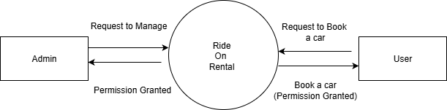

DFD – Data Flow Diagram

Zero level

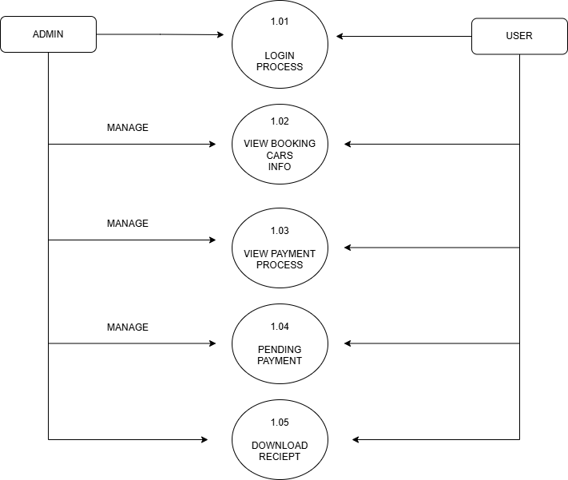

First level-

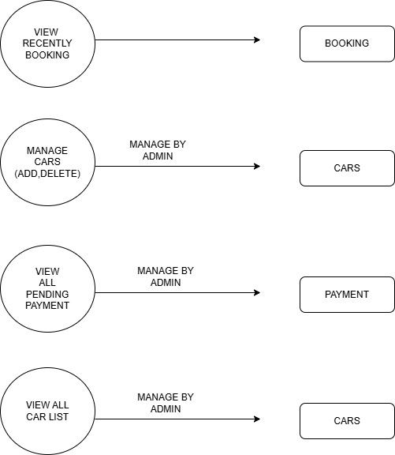

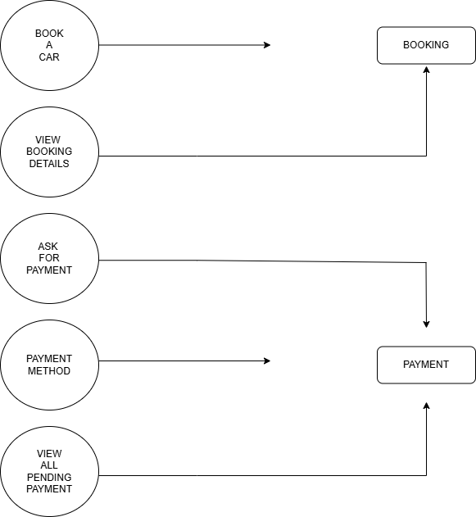

Er-Diagram-

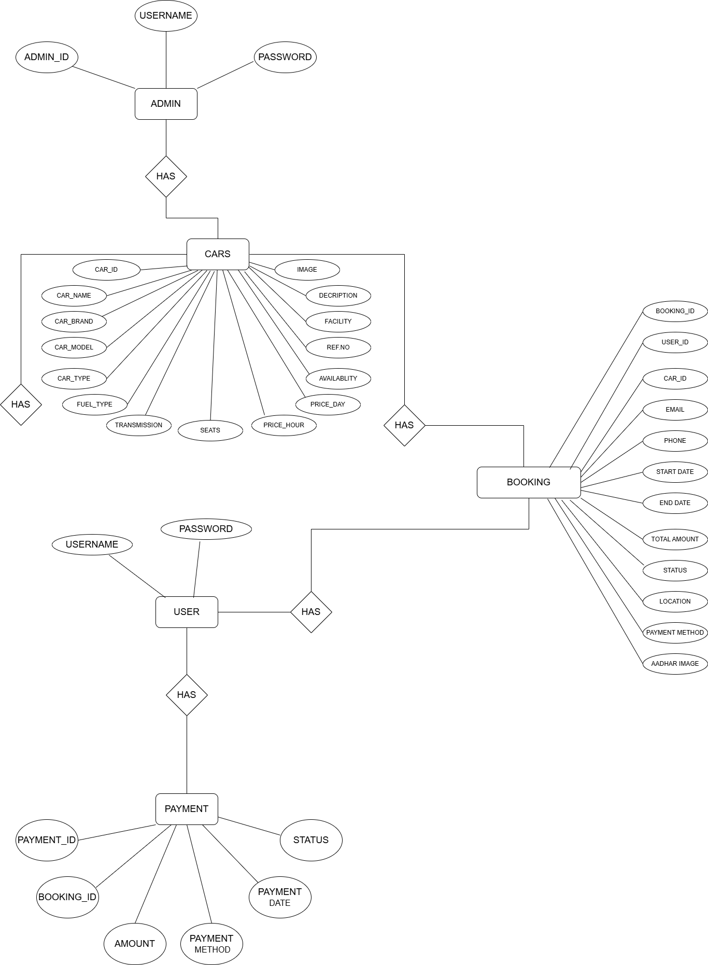

[7] Screen shot & code explaination

* User-side

Index.php

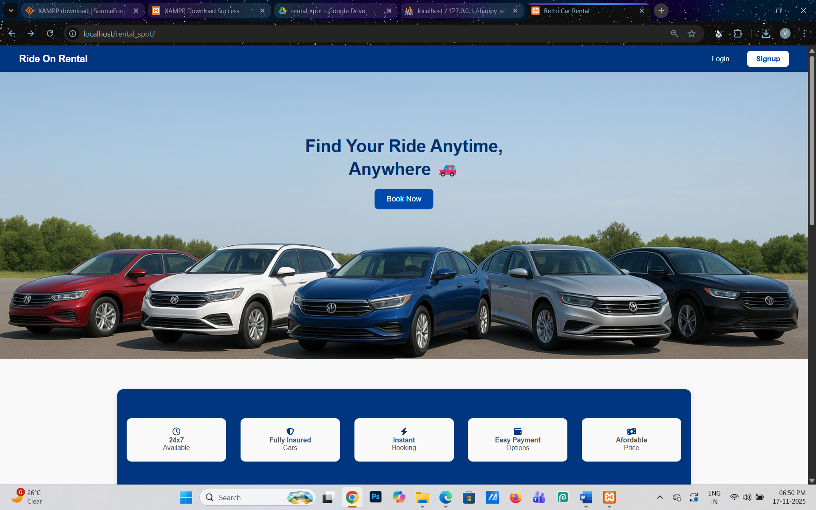

* This is the index page of our website.Users can see the facilities and steps for booking a car.
* User can login/signup.

Login.php

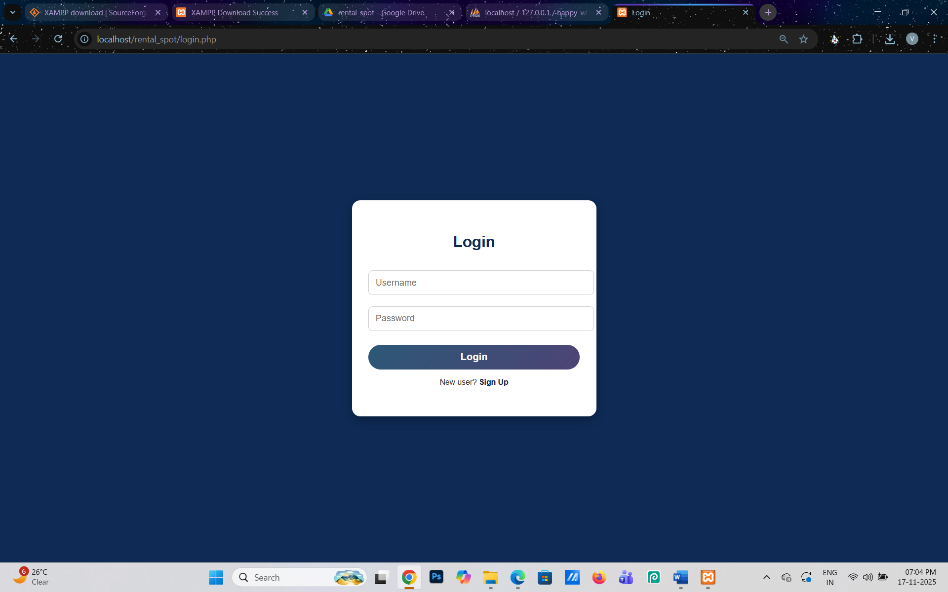

* This is the login page.user can login.

Dashboard.php

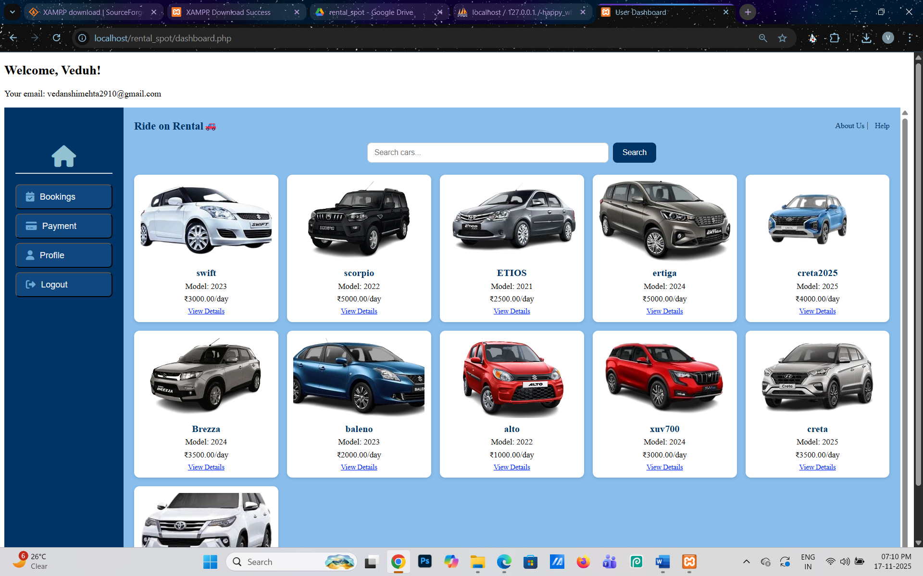

* This is the Dashboard.php page of our website.
* User can book a car , view their booking history , view payment history , set their profile.
* User see the different cars and their categories.

Payment.php

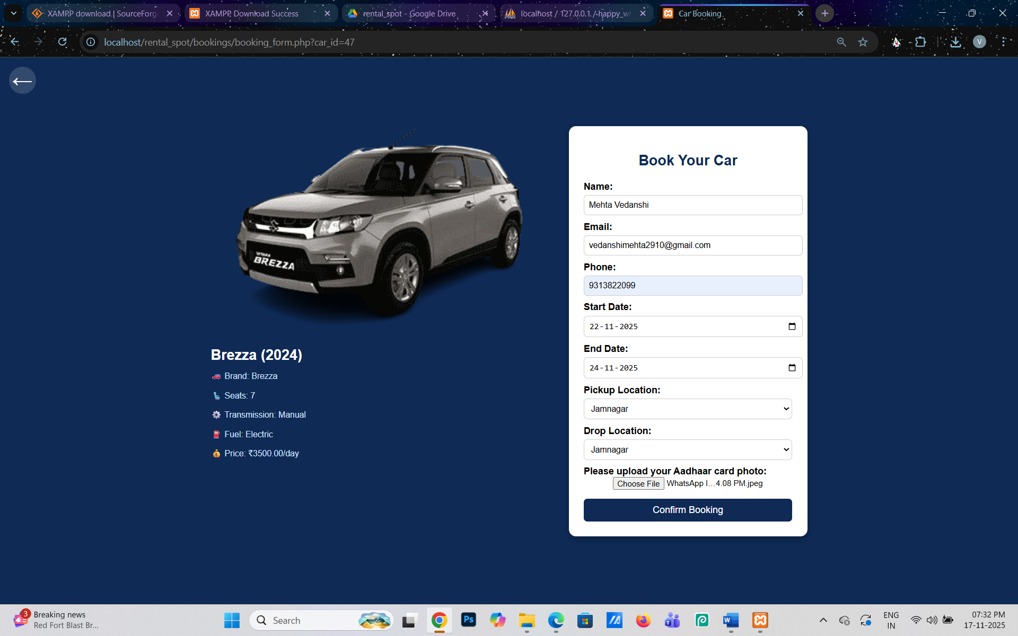

* This is the booking form page of our website.
* User book a car of their choice.

Payment.php

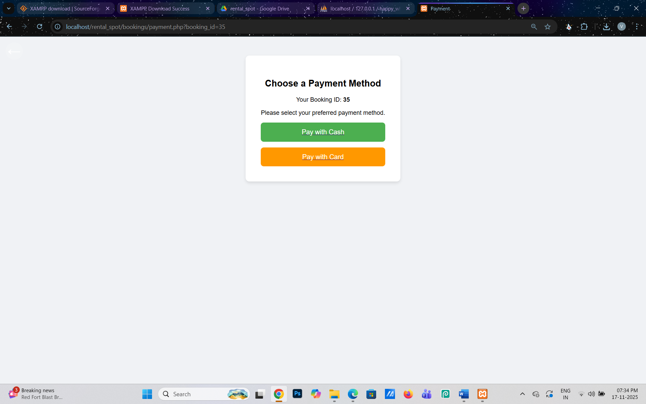

* This is the payment.php page of our website.
* User choose the payment method.

Receipt.php

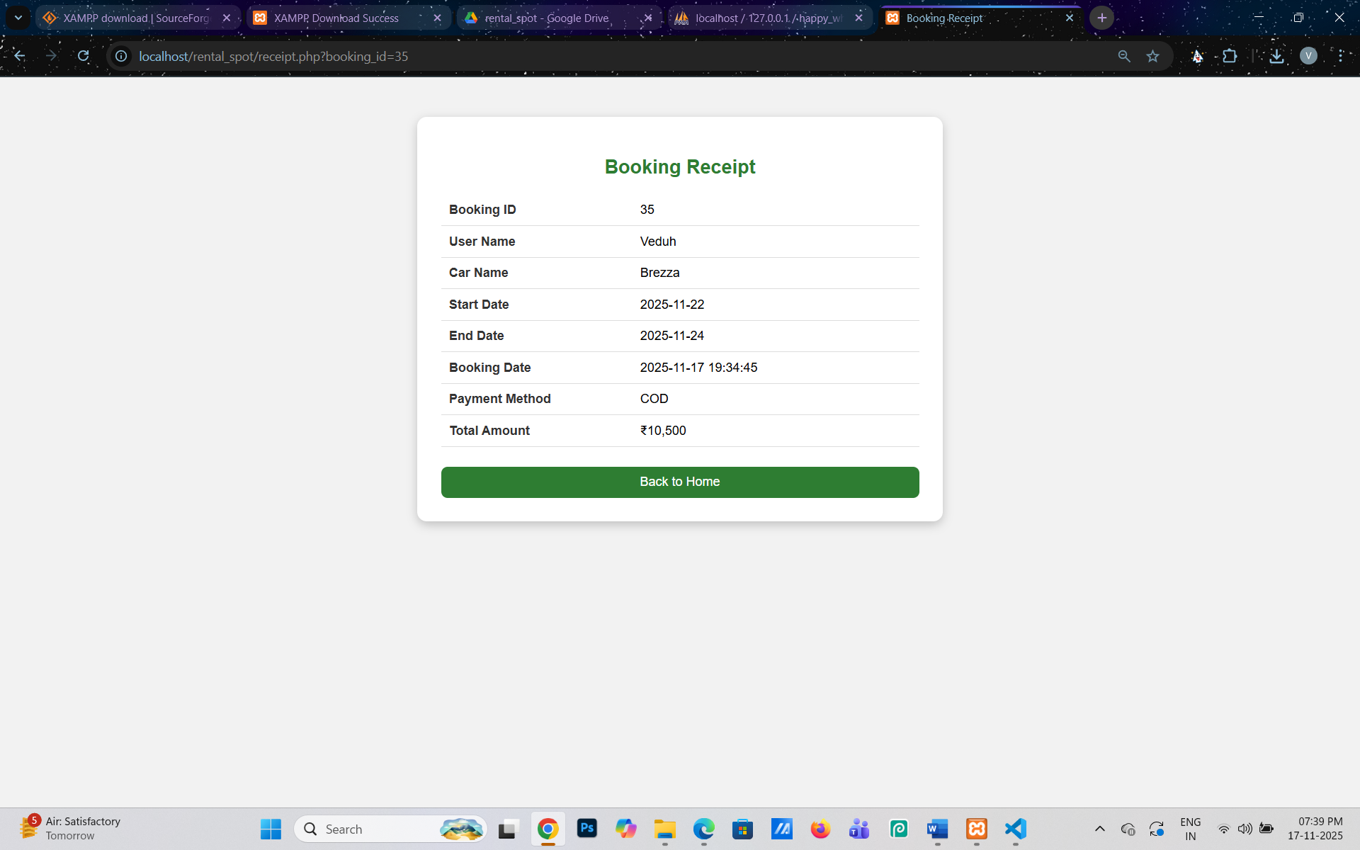

* This is the Receipt.php page of our car rental website.
* User view their booking details here.

Admin-side-

Index.php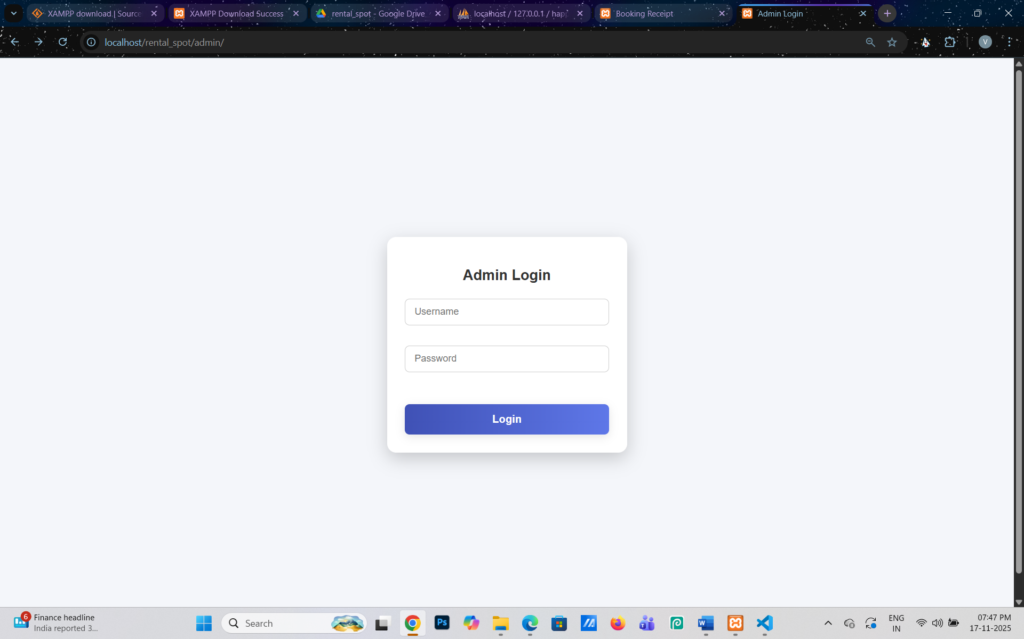

* In admin side, this is the index.php page.
* Only admin can login to admin panel.

Dashboard.php

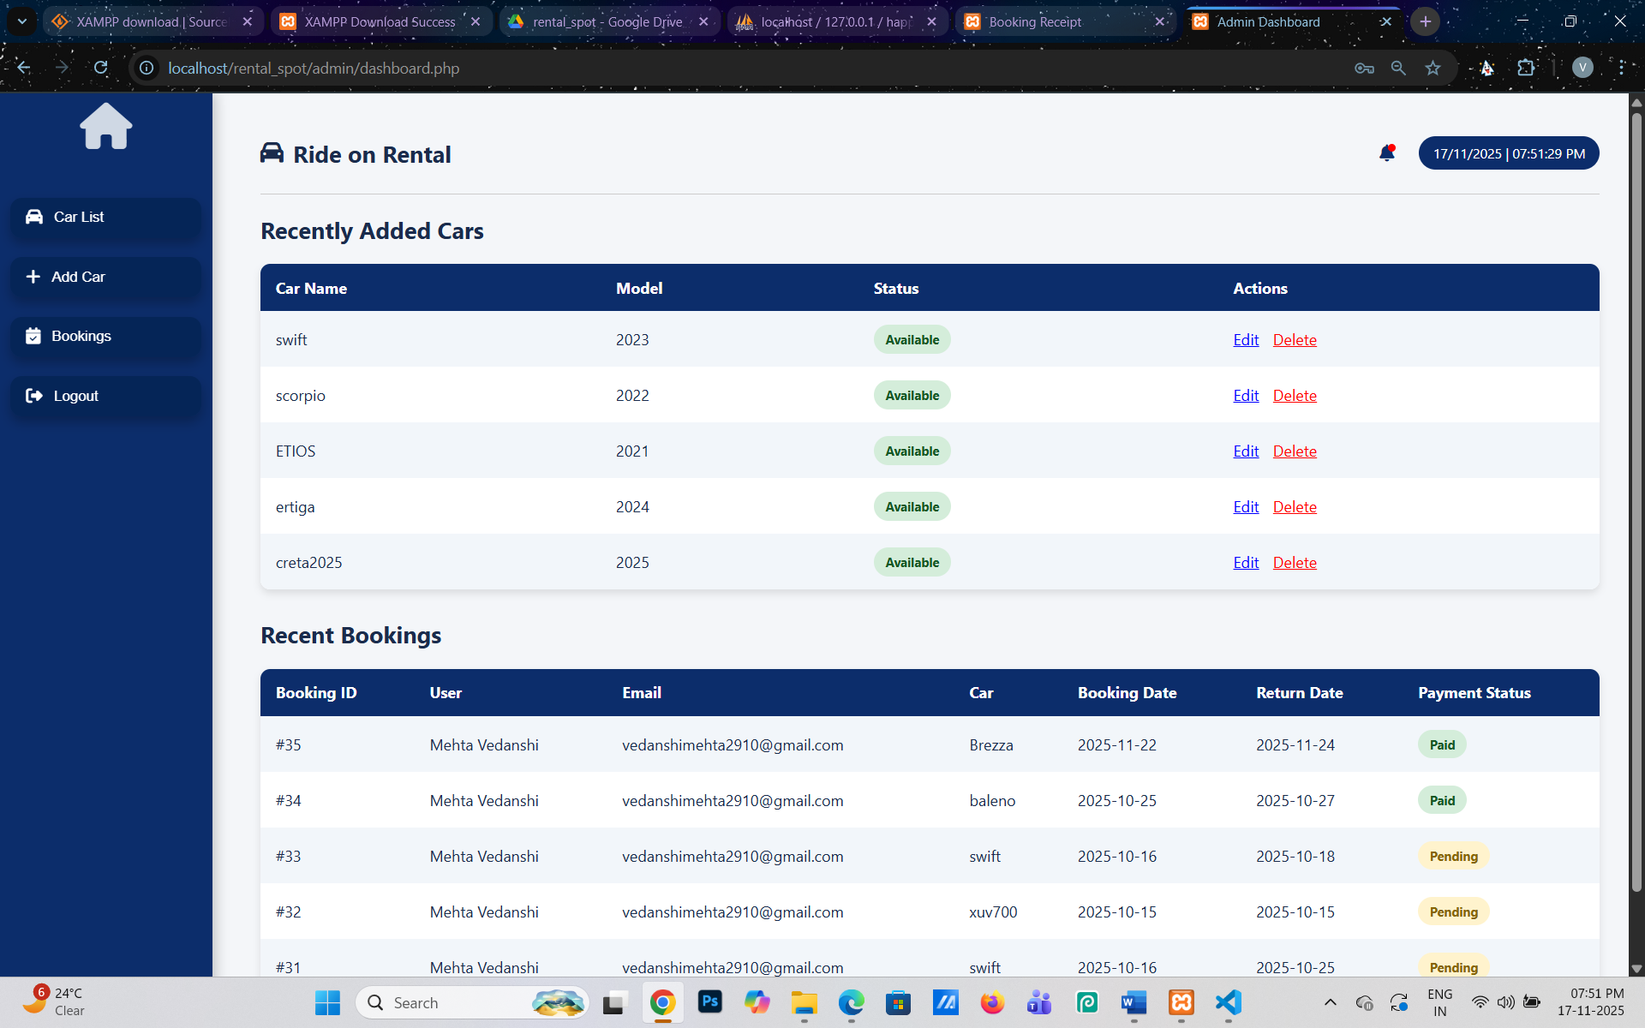

* This is the dashboard.php page of admin side.
* Admin can add a car and see recent bookings.
* Admin can edit or delete the recently car.
* Admin can see the all user booking history.
* Admin see the all car list from the left side.

Testing & reasults

Testing is vital for the success of any system. The purpose of system testing is to identify & correct errors in candidate’s system. System testing makes a logicalassumption that if all the part of the system is correct, the goal will be successful achieved. Inadequate testing leads to prone errors even after months of successful system implementation.

1. Program Testing
   * All the programs in the System have been checked & all the syntaxes as well as the logical errors had been removed. All the inputs have been tested with dummy data. The adequate care is taken for the outputs that meet the user requirements.
2. Validation checks
   * All the checks for the validation have been done. Each& every data is Checked for validation and is processed by the system. The system is protected against unauthorized or faulty data. The validations are also been confirmed with the user.
3. Procedure & validation testing
   * Dummy data was prepared and compiled in the normal manual way. The same was entered in the computerized system and compared with the manual data to ascertain the accuracy.
   * Simultaneously invalid data were also entered to ascertain the efficiency ofcomputerized system and as per testing these results were getting as result.

* Output consideration
  + All the reports were produced & documented as per the general requirements of business organizations. The reports are in the required as per the usualrequirements. The formats, depending on the needof organization, can vary as compared to designed formats.

Conclusion -

In this project, we successfully analyzed, designed, and implemented the proposed system. Through various phases such as system analysis, system design, ER diagrams, DFDs, and testing, the entire workflow of the application was clearly understood and developed.

Overall, the project helped in understanding real-life software development steps from identifying the problem to building and testing a complete working solution. It also improved our practical knowledge of databases, programming, and system design.

**Future Scope -**

The system can be further improved by adding more advanced features, optimizing performance, enhancing security, and making the interface more user-friendly. Additional modules and automation can also be introduced in the future to make the system more flexible and scalable.